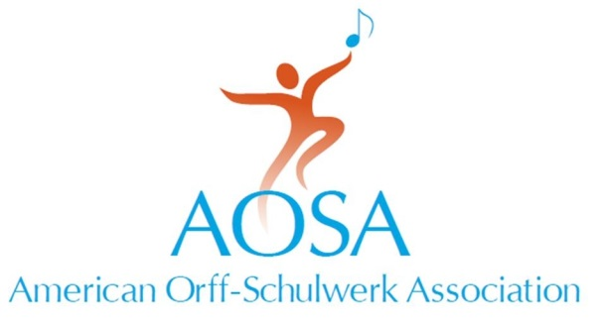
147 Bell Street Suite 300
Chagrin Falls, OH 44022
440.600.7329 fax 440.600.7332
info@aosa.org • www.aosa.org

Distinguished Service Award
American Orff-Schulwerk Association

Person Being Nominated:

Name:
Position:
Address:
Phone:

This Nomination Is Being Submitted By:

Name:
Position:
Address:

Phone:
AOSA Chapter:
AOSA Membership #:

Please attach a letter describing how the nominee has given exemplary service to AOSA and the growth of Orff Schulwerk in the United States. In addition, please list the names of three, but no more than three people, who will write letters of recommendation based on the criteria listed. All materials supporting the nomination must be received at AOSA Headquarters by August 1.

References:

Name:
Name:
Name:

Distinguished Service Award
American Orff-Schulwerk Association

Purpose

To recognize and honor those who have given exemplary service to the American Orff-Schulwerk Association and contributed to the growth of Orff Schulwerk in the United States.

This honor bestows:
- Lifetime honorary membership with lifetime complimentary conference registration.
- Certificate of recognition.
- An award presented at a national conference.
- An opportunity to share philosophy and life experiences in Orff Schulwerk via videotape to be placed in AOSA archival and lending libraries.

Guidelines

1. Selection will be based on the following criteria:
- Nature and extent of active participation in and service to the American Orff-Schulwerk Association.
- Length and quality of involvement in the Orff Schulwerk movement.
- Impact of service on community, state, or nation.
- Impact on the growth and acceptance of AOSA aims and objectives.

2. Nominations may be made only by current members of AOSA. No current member of the AOSA National Board of Trustees may be nominated.

Nominations must be received at the AOSA Executive Headquarters by August 1 and must include three, but no more than three, letters of recommendation that should take into consideration the criteria listed.

3. The awards committee will present no more than 3 nominees to the National Board of Trustees at the September meeting for final selection.

No more than one award will be given during each year, but this does not mean that an award must be given every year.

4. A letter of acceptance is required of the recipient prior to the conference.

