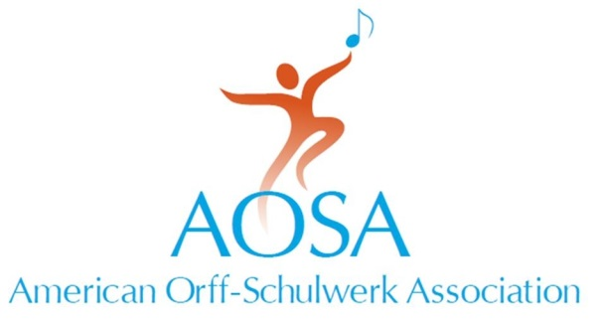
147 Bell Street Suite 300
Chagrin Falls, OH 44022
440.600.7329 fax 440.600.7332
info@aosa.org • www.aosa.org

Dear Music Industry Partner
Join us in San Diego, California for the
2015 AOSA Professional Development Conference
Waves of Learning
November 11–14, 2015
The AOSA Conference Committee is planning another amazing conference, building on the continued success each conference brings to the professional development of our AOSA members. Your company's involvement is key to delivering the best conference experience to our members while providing you direct access to your target market and driving your sales. It’s a win-win!
The Conference Committee has changed the Exhibit Hall to "The Marketplace." This name change is to show administrators what our attendees already understand. Our exhibitors don't just sell equipment and supplies, but offer the latest information through their education experts and consultants. With the name change, attendees can count one hour per day toward graduate credit contact hours.
Our Professional Development verification log will be printed in the conference book. Exhibitors may be asked to initial the form when that time slot is labeled "Marketplace." We're hoping attendees won't just dash and run, but stop and visit a moment about your newest products and resources. We hope this new program will increase traffic in the hall and provide another option to our PD sessions, concerts and evening events.
The Town and Country Resort and Convention Center Grand Hall will be your home in San Diego. We’re continuing the successful tradition of an Exhibit Grand Opening with the Welcome Ceremony leading the membership into the hall for a reception. We had great feedback on moving the opening time back to 11am, so will continue that for 2015. This earlier opening allows for more hours of contact time for you with conference participants
The Marketplace Hours
Thursday, 11/12
Open: 11:00 A.M. - 3:00 P.M.
Grand Opening: 5:30 P.M. - 7:30 P.M.
Friday, 11/13
Open: 9:00 A.M.– 5:00 P.M.
Designated: 2:30 – 3:45 P.M.
Saturday, 11/14
Open: 9:00 A.M. – 1:00 P.M.
Designated: 9:15 A.M. – 10:15 A.M.
Exhibitor setup will be Wednesday, November 11 from 9:00 A.M. to 4:00 P.M.
and Thursday, November 12 from 8:00 A.M. to 11:00 A.M.
Teardown is scheduled from 2:00–6:00 P.M. on Saturday, November 14.
The necessary forms to exhibit at the AOSA Professional Development Conference are attached. You also have the option of filling out your exhibit contract online. Click here to apply online. If you have forgotten your log in use either forgot links to either retrieve or reset your login.
If you elect to use the hard copy forms, please read over the information, complete the exhibit contract, and return it with the amount due to:
Regular or Express Delivery:
AOSA Headquarters
147 Bell Street, Suite #300
Chagrin Falls, OH 44022
Each exhibitor who submits its contract by May 15 will be entered in the drawing once for every booth space. For example, if you are renting six booths, your company will be entered in the drawing six times. The company that’s name is drawn first will be placed in its first choice booth(s). The next company drawn will be placed in its first choice booth(s) as well, as long as that location is available. If not, we will accommodate the company’s second choice. We will proceed in this fashion until all booths are assigned.
Contracts received after the due date, will NOT be included in the initial booth assignment process. Instead, these exhibitors will be assigned to the remaining booths on a first come, first serve basis.
When selecting your preferred booth location, please note that we do not allocate specific corner booths. You may request blocks of booths at the end of rows and there will be a $20 additional surcharge for each of those booths.
A reminder that current membership as an Industry Member is a requirement for booth assignment. If you need to bring your membership current, you have the option to pay the $120 industry membership dues with your exhibitor contract deposit or you can renew online.
Finally, note that the Town and Country Resort and Convention Center is a non-union facility. The Grand Hall has carpeting.
For additional information or assistance, contact Anna Pack, AOSA Associate Director, at (440) 600-7329 or anna@aosa.org.
We look forward to seeing you at the 2015 AOSA Professional Development Conference, Waves of Learning.
Sincerely,

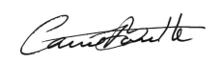
Carrie L. Barnette
Executive Director

