147 Bell Street Suite 300
Chagrin Falls, OH 44022
440.600.7329
education@aosa.org

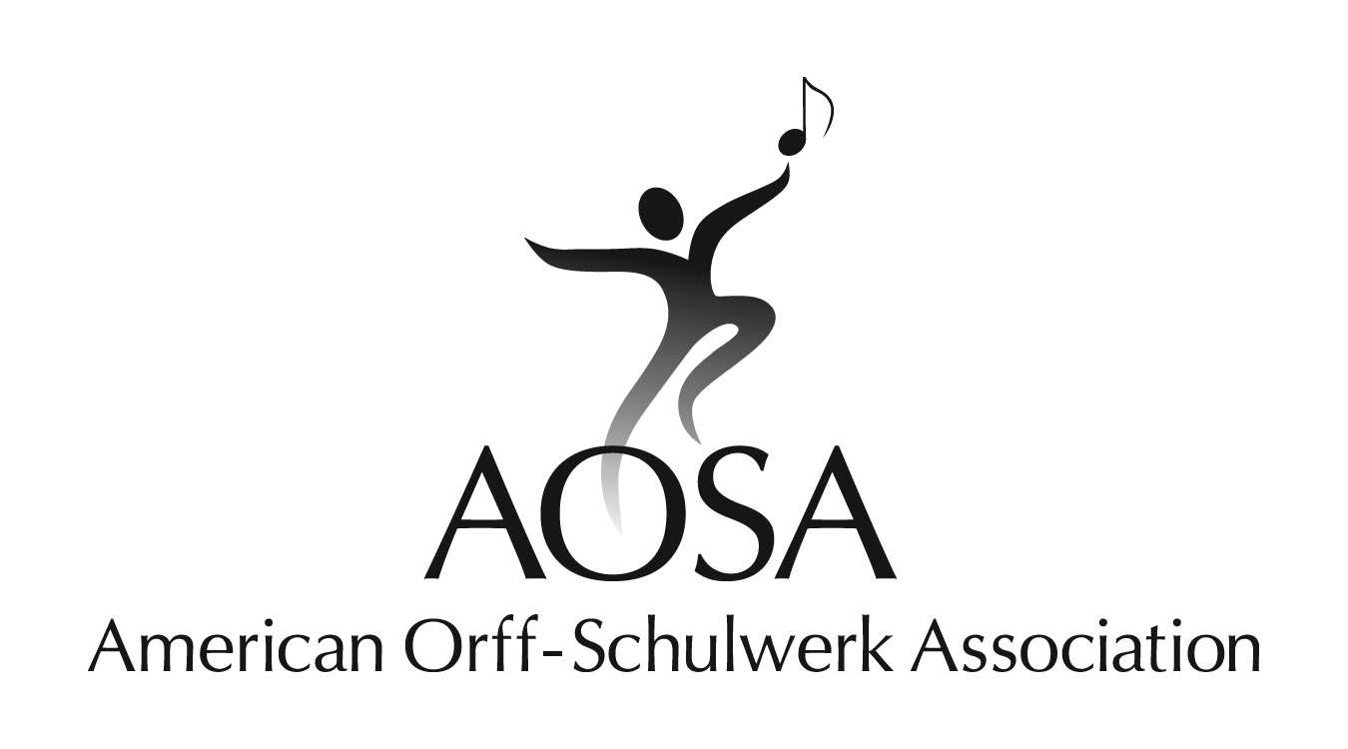

Dear Orff Schulwerk Teacher Education Course Directors,

As you plan and prepare for the AOSA Teacher Education courses for the summer of 2015, the AOSA Professional Development Committee would like to bring to your attention some key points regarding the course application process.

Completing the Course Approval Application Form
The Application for Course Approval form for summer 2015 is available on the AOSA web site Professional Development page. All forms should be submitted electronically to the Education Director in MS Word .DOC or .DOCX format
Applications should include the following to assure approval:
- Library subscription to the Orff Echo for the institution sponsoring the course
- Name and AOSA membership number of AOSA-approved instructors for your course. (Membership numbers can be found in the AOSA members directory in the Members Only section of the website. As you plan for your 2015 summer course, please verify that instructors are included in the on-line Approved Teacher Educator Roster. It is the individual teacher educator’s responsibility to see that all required documentation has been submitted for teacher approval.)
- Site location and address where the course will be held
- Contact information for the Orff Course Director
- Contact information for the Institution Contact Person
- Daily schedule, including required minimum hours for Basic, Movement, Recorder and Special Topics instruction. Please include all breaks longer than five minutes.
- Application fee of $50 sent to AOSA Headquarters

Class Size Requirements
AOSA requires minimum enrollment numbers for Teacher Education Levels courses as outlined in the “Handbook for Orff-Schulwerk Teacher Education Courses”:
Level I - 14; Level II - 8; Level III – 8
These numbers are important for a variety of reasons:
- the required class size provides participants an experience more closely resembling typical classroom ensembles
- it allows participants to hear and perform balanced vocal and instrumental ensemble work and to create movement in small and large group setting

AOSA does not determine whether a course will run. However, AOSA strongly urges that course directors voluntarily cancel under enrolled courses with a minimum of two weeks notice to participants. Courses that run without meeting the enrollment minimums will be placed under review status for the following year.

Courses under review that meet enrollment minimums the following year will be taken off review status. Courses that run without meeting enrollment minimums for a second year will not be approved the following year. Courses that cancel due to low enrollment are taken off review status and may be approved for the following year.
Approved teacher educators should not teach in a course that does not meet enrollment minimums.

Class Schedule
The scheduling of a class is directly related to the success students feel at the end of a course. Giving students enough time to process and practice information is vital to the exceptional experience that AOSA trusts all teacher education courses to be.
AOSA requires a minimum of 60 contact hours per level, not including lunch periods or break times of more than five minutes. Additionally, the course must meet over a minimum of ten days.
Please Note: Prior to 2014, some classes scheduled over the July 4th holiday included only nine days of instructional time. From 2015 on, the AOSA National Board of Trustees has announced that no new or continuing courses will be approved to run for nine days. AOSA suggests that alternate weeks be chosen for courses that fall in this category or that the ten-day requirement be fulfilled by holding classes on a Saturday, Sunday or the day the holiday is celebrated if July 4th occurs on a weekend.

Regarding the new AOSA Teacher Education Curriculum
For 2015, all teacher education courses should operate under the new AOSA Teacher Education Curriculum. The curriculum document can be found on the members page of the AOSA website under the tab Course Instructors.

Course Sequence
Students progressing through the AOSA Levels Courses are advised to schedule their courses over sequential summers. Moving from course to course in the same year does not provide application opportunities in individual classroom settings, which is an essential time for practice and professional development as an Orff Schulwerk educator. Please communicate this to your instructors and students.

Meeting of the Minds and Teacher Education Sessions
The Professional Development Committee would like to invite course directors and instructors to several special sessions at the 2015 Professional Development Conference in Nashville.
- Meeting of the Minds: The Role of Improvisation in the AOSA Orff Schulwerk Teacher Education Curriculum
Saturday, November 8, 10:30 – 11:45 a.m.
Panelists: Carol Erion, Jane Frazee, Doug Goodkin, Mary Shamrock

- Roundtable for AOSA Endorsed Teacher Educators: Levels Course Curriculum
Join in dialogue with other AOSA endorsed Teacher Educators in focus groups relating to each
level of Basic as well as Recorder and Movement. Informal discussions to address understanding related to specifics of the Teacher Education Curriculum. Saturday, November 8, 1:00 – 2:15 p.m. Facilitator: Karen Medley

- Teaching Level 1 Basic in an Orff Schulwerk Course
Explore and discuss activities in skill development, pedagogy, ensemble, and
improvisation, following the AOSA approved curriculum. Register for all 4 sessions. Session 1: Thursday, Nov. 6, 8:00 – 9:15 a.m.
Session 2: Thursday, Nov. 6, 9:45 – 10:45 a.m.
Session 3: Friday, Nov. 7, 8:00 – 9:15 a.m.
Session 4: Friday, Nov. 7, 9:45 – 11:00 a.m.
Session presenters: Cindy Hall and Joyce Stephansky

- Teaching Movement in an Orff Schulwerk Course
Explore and discuss activities in skill development, pedagogy, ensemble, and
improvisation, following AOSA approved curriculum. Register for all 4 sessions.
Session 1: Thursday, Nov. 6, 12:30 – 1:45 p.m.
Session 2: Thursday, Nov. 6, 2:15 – 3:30 p.m.
Session 3: Friday, Nov. 7, 12:30 – 1:45 p.m.
Session 4: Friday, Nov. 7, 3:45 – 5:00 p.m.
Session presenters: Beth Nelson and Sarah Richardson

These are wonderful opportunities to discuss and learn some of the ways in which AOSA can strengthen and improve teacher education courses around the country.
The Professional Development Committee greatly appreciates the dedication and effort of our course directors and instructors who provide on-going, high-quality professional development based in the AOSA Teacher Education Curriculum. Thank you for providing this invaluable service to your students and to AOSA.

Sincerely,

Jay Broeker, Chair
AOSA Professional Development Committee
broekerAOSA@gmail.com
John Buschiazzo, Lisa Hewitt, Kay Judson, Betsy Kipperman, and Lisa Sullivan, committee members
Steven Calantropio, AOSA Education Director

