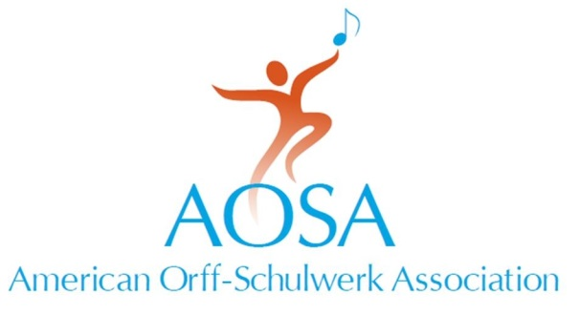
147 Bell Street Suite 300
Chagrin Falls, OH 44022
440.600.7329 fax 440.600.7332
info@aosa.org • www.aosa.org

Excellence in Research Award
American Orff-Schulwerk Association

Purpose

To recognize and honor those researchers who have a distinguished record of scholarship and sustained engagement in research activity that contributes to the principles and practices of Orff Schulwerk.

This honor bestows:
- Certificate of recognition
- A plaque presented at the annual AOSA Professional Development Conference

Selection Criteria

1. Selection will be based on one or more of the following criteria:
- A history of active participation in and service to the research community of the American Orff-Schulwerk Association.
- A record of juried research and publication in scholarly journals
- An outstanding dissertation or masters thesis related to Orff Schulwerk
- Research presentations at professional meetings
- Mentorship of graduate students and/or young researchers

Nominations

Person Being Nominated: This Nomination is being submitted by:

Name: ______________________ Name: ______________________

Position: _____________________ Position: ______________________

Address: _____________________ Address:______________________

Phone: _____________________ Phone: ______________________

Email: _____________________ Email: _______________________

AOSA Chapter: ________________

AOSA Membership #____________

Excellence in Research Award
American Orff-Schulwerk Association

a) Nominations for this award may be made by a current AOSA member who will
submit the following supporting materials:

- A personal recommendation letter describing how the nominee has engaged in scholarly and sustained research activity that has contributed to the principles and practices of Orff Schulwerk.

- The names and contact information of two additional references

- Candidate’s curriculum vitae

b) All nomination materials will be forwarded to AOSA Headquarters by
August 1st.

c) Members of the Research and RIG committees will collaboratively
review all materials. Prior to the September NBT meeting, they will
forward a recommendation of approval of the Excellence in Research
Award to the Executive Committee for their final endorsement.

d) No more than one award will be given during each year, but this does
not mean that an award must be given every year.
__________________________________

Thank you to the authors of Orff Schulwerk: Reflections and Directions (2013) for donating the proceeds of this book to create the AOSA Researcher Award.

