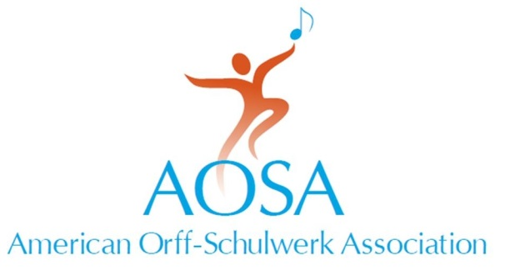
147 Bell Street Suite 300
Chagrin Falls, OH 44022
440.600.7329 fax 440.600.7332
info@aosa.org • www.aosa.org

Distinguished Service Award
American Orff-Schulwerk Association

Person Being Nominated:

Name:
Position:
Address:
Phone:

This Nomination Is Being Submitted By:

Name:
Position:
Address:

Phone:
AOSA Chapter:
AOSA Membership #:

Please attach a letter describing how the nominee has given exemplary service to AOSA and the growth of Orff Schulwerk in the United States. In addition, please list the names of three, but no more than three people, who will write letters of recommendation based on the criteria provided. Recommendations submitted by current NBT members or AOSA staff will not be considered. All materials supporting the nomination must be received at AOSA Headquarters by August 1.

References:

Name:
Name:
Name:

Distinguished Service Award
American Orff-Schulwerk Association

Purpose

The Distinguished Service Award is intended to recognize and honor those who have supported the mission of AOSA through exemplary service at the national level and who have contributed to the growth of Orff Schulwerk in the United States.

This honor bestows:
- A lifetime honorary membership with lifetime complimentary AOSA Conference registration.
- A certificate of recognition.
- An award presented at a national AOSA Professional Development Conference.
- An opportunity to share philosophy and life experiences in Orff Schulwerk via the AOSA website and publications.

Guidelines

- Selection will be based on the following criteria:
  - Nature and extent of active participation in and service to the American Orff-Schulwerk Association.
  - Length and quality of involvement in the Orff Schulwerk movement.
  - Impact of service at the national level.
  - Impact on the growth and acceptance of AOSA’s mission.

- Nominations may be made by current members of AOSA only. No current member of the AOSA National Board of Trustees may be nominated.

- Nominations must be received at the AOSA Executive Headquarters by August 1st and must include three, but no more than three, letters of recommendation that should take into consideration the criteria listed. Recommendations submitted by current NBT members or AOSA staff will not be considered.

- The awards committee will present no more than three nominees to the National Board of Trustees at the September meeting for final selection.
  - No more than one award will be presented in any given year, and the Board may elect to present no awards in a given year.

- Written acceptance is required of the recipient prior to the conference

