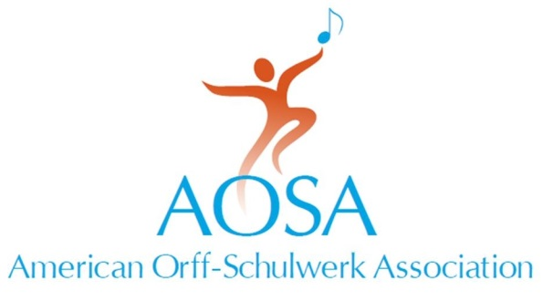

147 Bell Street Suite 300
Chagrin Falls, OH 44022
440.600.7329 fax 440.600.7332
info@aosa.org • www.aosa.org

Grassroots Impact Award
American Orff-Schulwerk Association

Person Being Nominated:

Name:
Position:
Address:
Phone:

This Nomination Is Being Submitted By:

Name:
Position:
Address:

Phone:
AOSA Chapter:
AOSA Membership #:

Please attach a letter describing how the nominee has given exemplary service to AOSA and to the growth of Orff Schulwerk in the United States. In addition, please list the names of three, but no more than three people, who will write letters of recommendation based on the criteria provided. Recommendations submitted by current NBT members or AOSA staff will not be considered. All materials supporting the nomination must be received at AOSA Headquarters by August 1.

References:

Name:
Name:
Name:

Grassroots Impact Award
American Orff-Schulwerk Association

Purpose

The Grassroots Impact Award is intended to recognize and honor those who have supported the mission of AOSA through exemplary service at the local and regional levels.

This honor bestows:
- A certificate of recognition.
- Recognition at an AOSA Professional Development Conference.

Guidelines

- Selection will be based upon the following criteria:
  - Membership in AOSA.
  - Involvement as a chapter member and leader.
  - Impact of service at the local chapter and regional levels.
  - Impact on the growth and acceptance of AOSA’s aims and objectives.

- Nominations may be made by current members of AOSA only. No current member of the AOSA National Board of Trustees may be nominated.

- Priority will be given to candidates from the current year’s Conference host region.

- Nominations must be received at the AOSA Executive Headquarters by August 1st and must include three letters of recommendation. Recommendations should support the outlined award criteria. Recommendations submitted by current NBT members or AOSA staff will not be considered.

- The Leadership Development and Nominations Committee will present no more than three nominees to the National Board of Trustees for consideration at the September Board meeting. No more than two awards may be presented in any given year, and the Board may elect to present no awards in a given year.

- A letter of acceptance is required of the recipient prior to the annual Conference.

