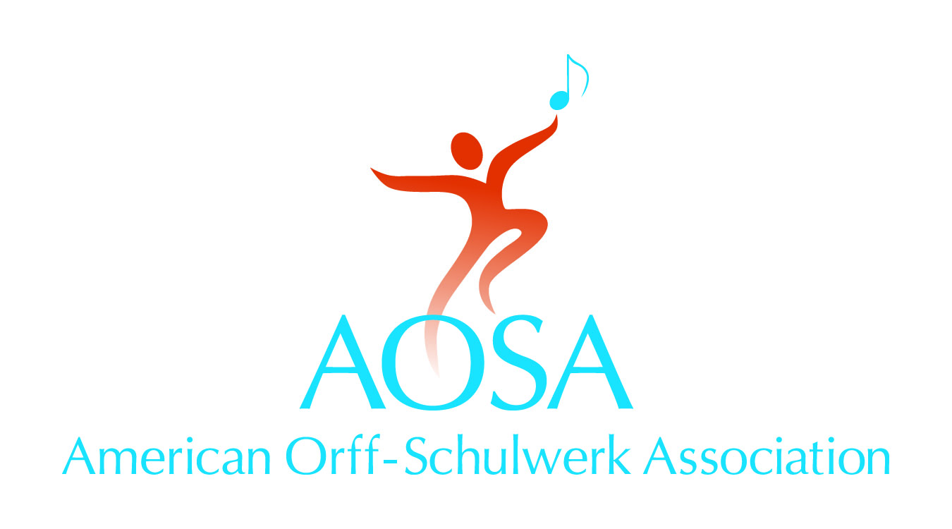

147 Bell Street Ste. 300
Chagrin Falls, OH 44022
(440) 600-7329
info@aosa.org • www.aosa.org

Video and Photo Release Form

I, (name),
of (address, city, state, zip) give permission for my child's photograph to appear in AOSA publications and print products. Furthermore, I understand that AOSA uses photos from its publications from time to time to depict music education on its Web site. If this photo is used for that purpose, I grant that permission as well.
Child’s Name

School

Grade Teacher

Date
Signature of parent/legal guardian

Printed name of parent/legal guardian

E-mail address Phone

For Office Use Only
Photo appeared in
Publication
Page
Position

