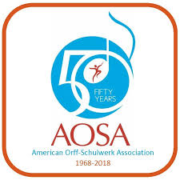 | AOSA Professional Development Conference  November 7 – 10, 2018  Title and  Presenter(s) Name(s) Here

Please note: Online session notes are limited to a maximum of 4 pages. Please do not alter the settings of this template. (However, you may delete this reminder!)

